Table of Contents
List of Tables 2
Introduction 3
System Analysis 3
Type of system 3
The objective 3
Elements of the system 3
Variables of the system 3
Input Parameters 3
Performance Indicators 4
Constraints of the system 4
Working hours 4
Data Collection and Analysis 4
Conceptual Model 5
Simulation Modeling of Restaurant in Simio 5
Model Entities 5
Source Block and Arrival Rate 5
Take Orders Process 6
Collect Orders 8
Tables and Animation 9
Results of Current State 9
Results of Alternative Scenarios 10
Validation 11
Verification 11
Executive Summary 11

List of Figures
Figure 1 Developed simulation model in Simio 5
Figure 2 Inputs of the source block 6
Figure 3 Rate table created in Simio 6
Figure 4 Inputs of the take orders separate block 7
Figure 5 properties of PrepareOrders (Server) 8
Figure 6 CollectOrder Combiner 9
Figure 7 State assignment for sitting position animation of customers 9
Figure 8 Results of the current state 10
Figure 9 Results of all scenarios 10

List of Tables
Table 1 Number of customer arrivals between each 1 hour interval 4

Analysis of Fast-food Restaurant Operations with Simulation Models using Simio

Introduction
In this case study, a simulation model of fast-food restaurant will be developed to better understand the behavior of the system under certain condition. The main problem with the fast-food restaurant is the long waiting times of the customers. The customers have to wait in the queue for giving their orders and then wait once again for their order to be prepared. The managers in the restaurant state that total average waiting time for a customer is more than 10 minutes. The simulation model of the restaurant will be developed to analyze how the waiting times could be reduced and how much could be reduced in various scenarios.

System Analysis
The system that will be analyzed in this case study is fast food restaurant called “XXx” located in XYX

Type of system
In this case study the system that will be analyzed is dynamic since the states of the variables such as length of queues number of customers in the change throughout the simulation run. The system is stochastic due the randomness in the inter-arrival times and the processing of cashier and order preparation processes. Finally the studied system is open since the entities which are customer can enter and exit the system.

The objective
As stated by the managers of the restaurant the objective of this case study is find the minimum number of employees for cashiers and cooks that will result in the total average waiting time of the customers below 5 minutes.

Elements of the system
The elements of the system are customers, cooks, cashiers and tables

Variables of the system
The system has the following variables queue lengths, service times, average waiting times etc

Input Parameters
The controllable inputs of the system are the number of cashiers and number of cooks. Other input parameters such as customer interarrival times and service times are not controllable.

Performance Indicators
The main performance indicator that will be used to compare different scenarios is the average total waiting time of the customer. This indicator will be calculated with the following formula:
Waiting time at cashier + waiting time for preparation of order
Other performance indicators which will allow us to better understand the behavior of the system is utilization rates of the cook and cashier resources.

Constraints of the system
The constraints of the system is as follows, there can be maximum 5 staff working at the kitchen at any given time. Maximum number of cashiers that can work in the restaurant is limited to 3. Finally the seating capacity of the restaurant is 76.

Working hours
The restaurant opens at 9 am and runs for 13 hours until 10 pm.

Data Collection and Analysis
For the customer arrivals the data has been collected for one whole day. The number of arrivals between each 1 hour interval is presented in the Table 1 below.
Table 1 Number of customer arrivals between each 1 hour interval
From | To | # of arrivals
9:00 AM | 10:00 AM | 20
10:00 AM | 11:00 AM | 26
11:00 AM | 12:00 PM | 28
12:00 PM | 1:00 PM | 29
1:00 PM | 2:00 PM | 33
2:00 PM | 3:00 PM | 24
3:00 PM | 4:00 PM | 23
4:00 PM | 5:00 PM | 21
5:00 PM | 6:00 PM | 27
6:00 PM | 7:00 PM | 32
7:00 PM | 8:00 PM | 34
8:00 PM | 9:00 PM | 18
9:00 PM | 10:00 PM | 16

The data for cashier and cooking process is collected by stop watch and the collected data is validated with the managers from the company. By analyzing the collected data statistically and reviewing the results of statistical analysis with managers of the restaurant, following distributiosn are found the best represent each process:
Cashier: Random.Triangular(0.8 , 0.9 ,1.5 )
Order Preperation: Random.Triangular( 3 , 4 , 5 ) minutes

Conceptual Model
The steps for the logic of the conceptual model for the system is described as follows:
Customers enter to restaurant with a varying arrival rate for each hour interval. The customers get in the cashier queue to place their orders. Once they place their order, the kitchen staff start work on preparing the meal. Once the meal is ready the customer grad their meal and sit at an empty seat at the tables area. After completing eating the meal, the customer leaves to restaurant.

Simulation Modeling of Restaurant in Simio
The layout of the restaurant and the developed simulation model in Simio can be observed in the figure below.
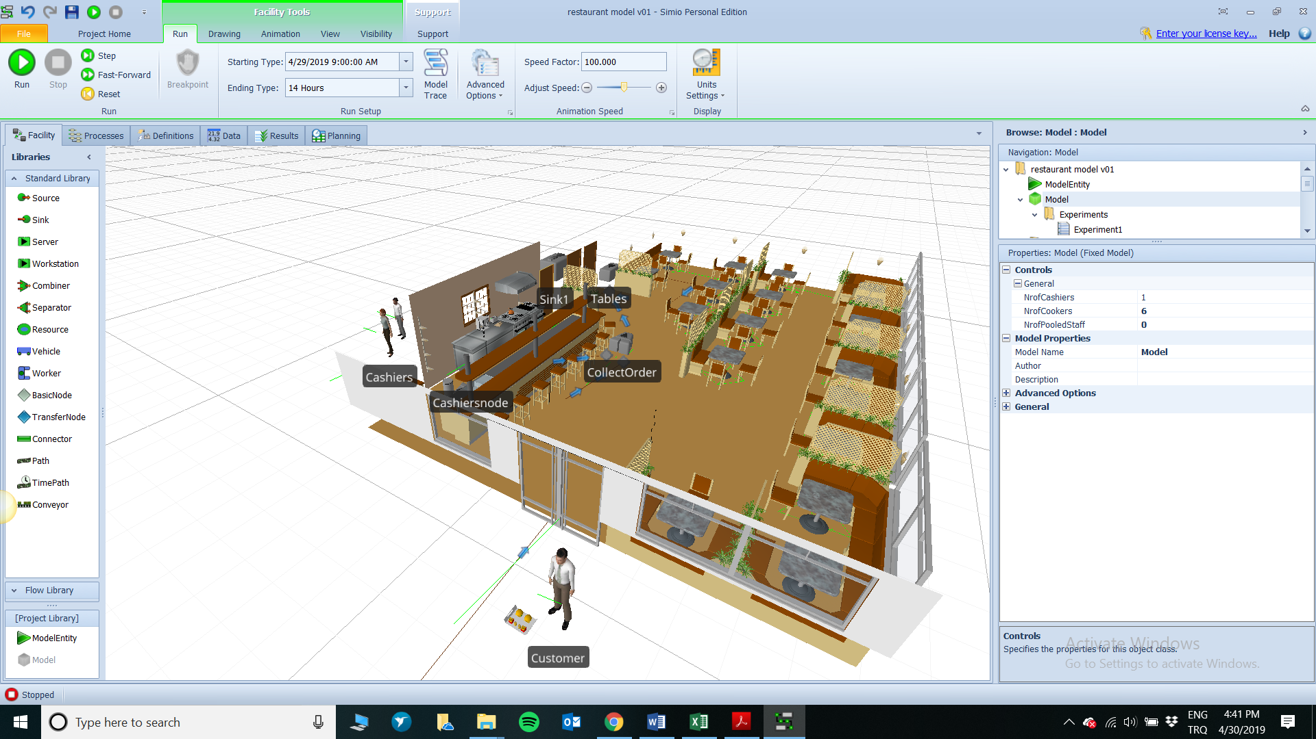
Figure 1 Developed simulation model in Simio
The simulation model is developed as follows:

Model Entities
The entity that flows through the system is the customer therefore a Model Entities is added into the model and named as “Customer”. A second entity that is created in the system is the meal. Therefore a 3D symbol appropriate for the customer and the meal are added to this entities.

Source Block and Arrival Rate
In Simio source blocks are used to create entities. In our model we used source block to create the customers as seen in Figure. The arrival rate of the customers vary throughout the day. Therefore in order to model this, a rate table is called RateTable1 is created under data tab. The arrival rate of the customers is inputted in accordance to the collected data presented in Table 1. The inputs of the arrival rate table can be observed in Figure 2.
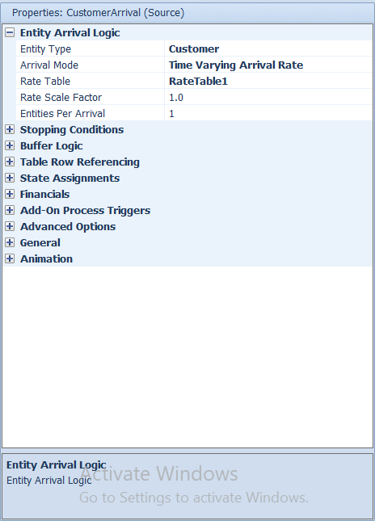
Figure 2 Inputs of the source block
The rate table created in Simio for arrival times of the customers in each 1 hours arrival can be seen in Figure 3
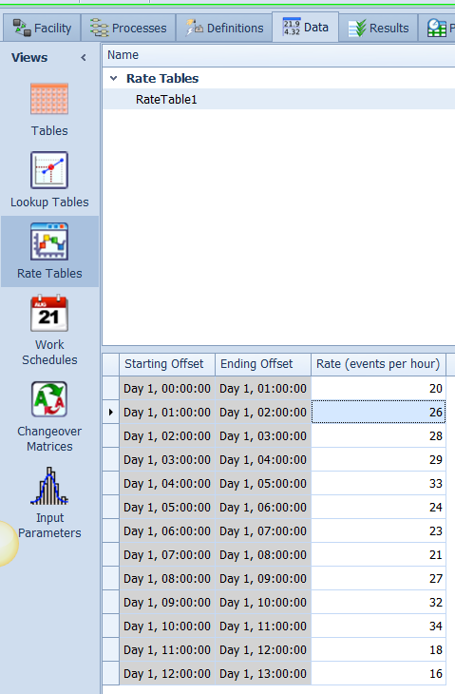
Figure 3 Rate table created in Simio

Take Orders Process
For the take orders process a separator block is used. Because the customers will be served by the cashier in this process and they will give their order which will be cooked in the kitchen. Therefore the order that will be given by the customer is another entity will be processed by the cooks in the kitchen and turned into the meal after completing the cooking process. Once the meal is ready, it should be combined with the customer therefore a combiner also required to combine the meal with the customer in the next steps.
The source block is connected to the input node of the separator block with a path. Therefore the customers will enter the take orders separator block and two entities will come out of the block, the customer will exit the main output node and the meal (order) will exit the member output of the separator block. The properties inputted into the separator block can be seen in Figure 4 below.
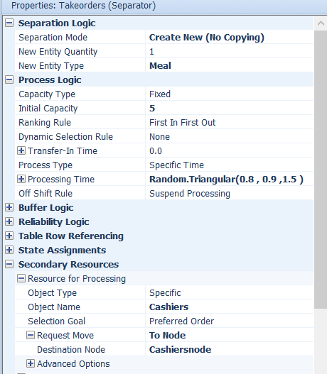
Figure 4 Inputs of the take orders separate block
Taking orders process requires cashiers as resources. Therefore the two workers are added to the simulation model, one for the cashiers and one for the cooks. For the secondary resources property of take orders separator block Cashiers object is selected as seen in Figure 4. Furthermore, a new transfernode is added to the model for the standing place of the cashiers. The name of this node is set to “Cashiersnode” and request move property of the separator block is set the this node as. destination node as seen in Figure 4. The processing time of the cashiers are set to random.triangular (0.8,0.9,1.5) according to analysis of the collected data.
The member output of the take orders separator block is connected to the input node of prepare orders server block. The properties of the prepare orders block can be observed in Figure 5. In a similar fashion to take orders step, cooks are selected as the secondary resource of this process and a new transfernode is added to the model which is renamed to Kitchennode. And the request move destionation is set to this node as seen in Figure 5.
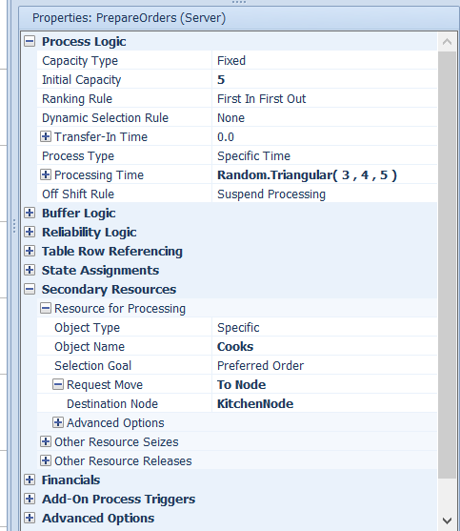
Figure 5 properties of PrepareOrders (Server)

Collect Orders
After preparing the meals customers collect their meal and sit on an empty seat at the tables area. Here a meal entity has to be combined with a customer entity. In order to model this a combiner block with processing time equal to zero minutes is used. Because it is assumed that once their meal is ready customers just take their tray proceed to tables area. The parent output of the takeorders (cashier) separator block is connected to parent input of the collect order combiner block. The output of the prepare orders server is connected to the member input of the collectorders combinor block. In that way one customer can be matched with the meal they ordered. The properties of the combinor block can be seen in the Figure 6 below.
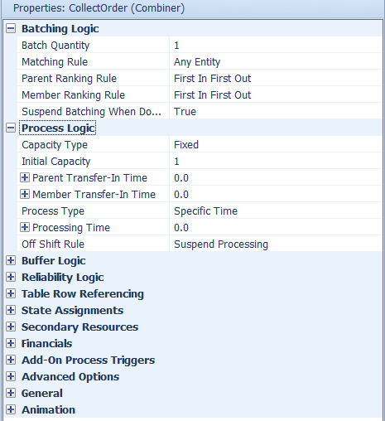
Figure 6 CollectOrder Combiner

Tables and Animation
Once the customers collect their meals they proceed to the area. According to collected and analyzed data the time a customer sits at a table area at seat is represented by the following formula “Random.Triangular(15,25,45)” The tables area have 76 seat therefore the capacity of the tables server is set to 76. Finally in order to change the animation of the customers to sitting position following state assignment shown in Figure 7 is added to the state assignments property of the tables server
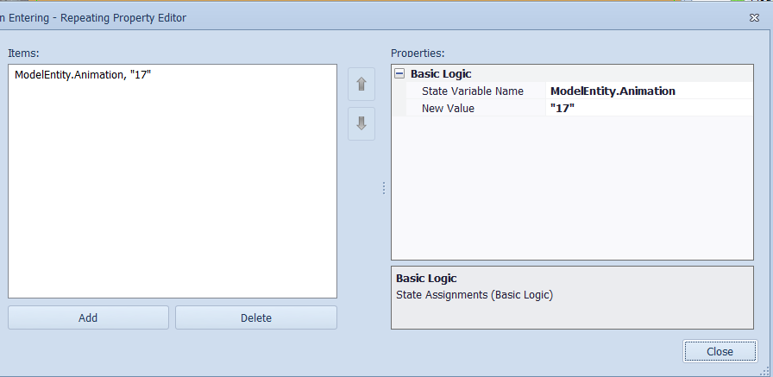
Figure 7 State assignment for sitting position animation of customers

Results of Current State
In order to get the results of the KPI’s mentioned in the previous section and compare them with various results a new experiment is created in the modeling modeling window. The initial number property of cashiers and cooks are added to as control parameters to the experiment by right clicking the property name on facility screen and choosing set referenced parameter option from the pop-up options.

Currently there is one cashier and two cooks working in the restaurant. Therefore the control parameters for number of cashiers is set to 1 and for number of cooks to 2. The simulation start time is set to 9 am and run length is set to 13 hours. The simulation is run with 100 in order to get statistically valid results
The results of the current state is as follows:
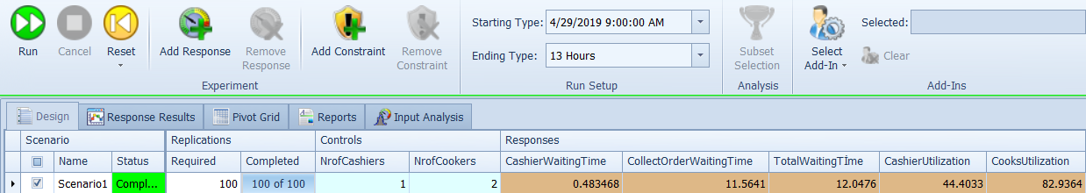
Figure 8 Results of the current state
As it can be observed in the results of the current state the waiting time at cashier is 0.48 minutes, however the waiting time at collectingorders is 11.56 minutes. Which indicates that the main cause of the waiting times is cooking process (prepare orders). In order to improve the system performance and reduce the waiting time more cooks should be added to the system. Therefore in order to understand the performance of the system a series of scenarios are created with each combination number of cashiers and cook where the limit for cooks is 5 and for cashiers 3.

Results of Alternative Scenarios
The design of the experiments and the results of each scenario with 100 replications is presented in Figure 9 below.
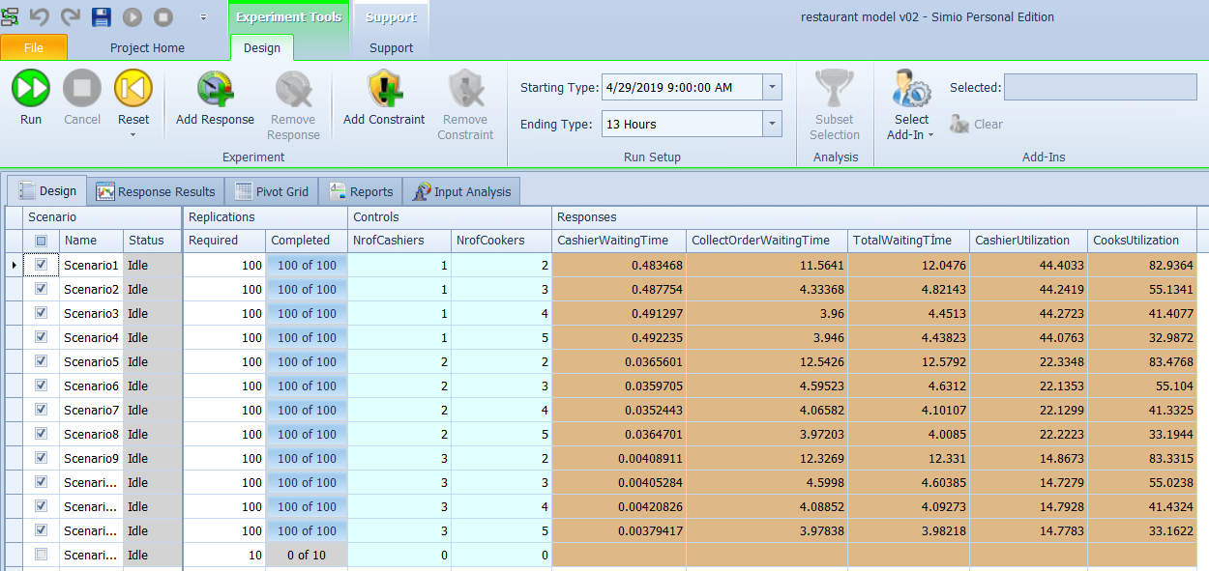
Figure 9 Results of all scenarios
The results of the scenarios showed that one additional cook is enough to reduce the total waiting time of customers under 5 minutes. It is also observed that in scenario1 (current state) the cooks were utilized 82 percent of the time currently which is quite high. With an additional cook (3 cooks in total) this value is reduced to 55 percent. The results in Figure 9 also indicate that there is no significant change in the total waiting time with more than 3 cooks.
The utilization rate of the cashiers was already low in the current state with 44.4% this indicates that no additional cashiers are required for this process.
Therefore we conclude that one additional cook will be sufficient for the restaurant management to reach their goal of reducing the waiting time of the customers below 5 minutes. The simulation model however enables the management to do even further analysis of the system in the future such as increased arrival rates of customers by only changing the data of the model. Therefore the benefit of this developed simulation model is not limited to current analysis and finding. It also enables any analysis of any scenario that may develop in the future.

Validation
The validation of the simulation model refers to the extend which the developed simulation model correctly represent the conceptual model. The model works exactly as the conceptual model described in the previous section. The behavior of the system is analyzed by carefully watching the entities flow throughout the system and creating animated labels that show the value of waiting times at each queue. By using this technique it was observed that all the performance indicators were calculated correctly. All the input value of data and code is also checked for error and no error was found

Verification
Verification step refers to the extend which the simulation model represents the actual system. In order to complete this part, an analysis with the managers from the restaurant is conducted on the behavior of the system and the results of the current state. The managers in the company stated that the results obtained for the waiting times were very similar to the actual waiting times. The utilization rates of the cashiers and the cooks are also validated with the managers. The managers also observed no strange behavior in the model as they watched the animation of the model slowly.

Executive Summary
In this case study the operations of a fast food restaurant was analyzed using simulation modeling technique. The problem stated by the managers was the long waiting times of the customers which were exceeding 10 minutes in the current state. The objective was to identify the minimum number of cashiers and cooks resulting in an average waiting time below 5 minutes. The results of the experiments showed that with one additional cook (total of 3 cooks) it is possible to reduce the total waiting time of the customers from 12 minutes to 4.8 minutes. The analysis also showed that more than 3 cooks did not reduce the waiting time significantly. Therefore it is advised to restaurant management to hire one more cook. The developed simulation model enables the management to conduct any analysis about the future state of their restaurant beyond the analysis conducted in this case study.

